Vern’s Technical Corner
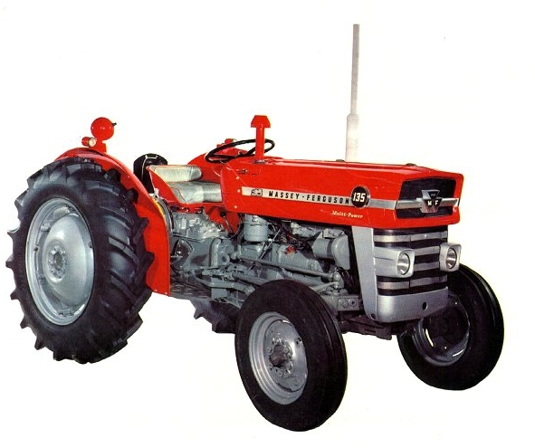
Massey Ferguson Model 135
This model was produced from 1965 till 1979 and replaced the very successful MF-35. It was available with a Perkins AD3.152 (2490cc) diesel engine or the Standard 87mm bore (2186.cc) petrol engine. The tractor was available with three forward and one reverse gear plus a Hi and Low Range selector on these gears, giving six forward and two reverse speeds. The Multi-power transmission doubles basic gear range giving 12 forward and 4 reverse gears. Multi Power ‘HIGH’ ratio obtained by a hydraulic clutch engagement of extra set of constant mesh gears.
Multi-Power explained.
With the Multi-power system there is one hydraulic clutch pack and also a freewheeling ratchet type assembly. When in Low Multi-power the hydraulic clutch is disengaged and the drive goes through a pair of gears into a freewheeling ratchet clutch which takes the drive to the gearbox. Moving the dash control to HIGH the hydraulic clutch is now engaged, taken the drive through a second set of gears increasing the output speed. As the input speed to the main gearbox has increased the LOW ratio freewheeling ratchet is disconnected.
The multi-power transmission gives an increase in speed or a 30% increase in torque when LOW is selected, the idea was operate in HIGH and when the going got tough you select LOW. There is no engine breaking in low Multi-power because of the ratchet clutch. When you move the transmission to high multi-power it locks up the hydraulic clutch and the hydraulic clutch gear drives another gear. Because the drive is now turning faster than through the low-multi ratchet clutch, this now becomes a free-wheeling device. It is for this reason that there is engine braking in high Multi-power, but no engine braking in low Multi-power.
This is also why if you are in high Multi-power going up a hill and you depress the clutch pedal whilst in gear, no roll-back can occur because of the ratchet clutch.( i.e.) both systems are locked together, engage the clutch and the transmission unlocks and move forward. This feature is also very handy ,( e.g.) when using a slasher going uphill and the slasher becomes over loaded (clogged) you only need to use the first stage of the clutch, as the transmission now locks and there is no need to apply the brakes.
The hydraulic multi-power clutch is not a torque converter, but is merely a multi-plate hydraulically operated clutch pack. The good thing about this is that there is no loss of power through to the gearbox. The clutch is a conventional clutch and so is the 3 speed gearbox.
There is some debate about the effectiveness or safety about the Multi power system. There are stories floating about of owners removing or disabling the Multi-power button as they considered it too dangerous. Usually this was felt because it was believed that you cannot engine brake when it is engaged. This is definitely the case in low range Multi-power, but not so in high range Multi-power
YEAR | SERIAL NUMBERS |  | YEAR | SERIAL NUMBERS
 | FROM | TO |  | FROM | TO
1965 | 101 | 30282 | 1972 | 403518 | 419582
1966 | 30283 | 67596 | 1972 | 419583 | 423708
1967 | 67597 | 93304 | 1974 | 423709 | 445601
1968 | 93305 | 117428 | 1974 | 445602 | 457865
1969 | 117439 | 141425 | 1976 | 457866 | 469334
1970 | 141426 | 162114 | 1977 | 469335 | 479191
1971 | 162115 | 179501 | 1978 | 479192 | 487349
1971 | 400001 | 403517 | 1979 | 487350 | 490714

Type/Country made:  England. | Engine: | Drawbar HP Power | Torque at crank: | PTO  HP | Type of engine: | Capacity: | Gears: | Tires front/rear: | Weight:
MF-135 | Perkins AD3.152 | 38 | 121.2lb/ft. @1360 rpm. | 42.9  @  2250 rpm. | inline 3 | 2490ccm | 6+2 / 12+4* | F: 6,00 x 16"/6 R: 11 x 28"/6 or 13 x 24"/6 | 1540-Kg
MF-135 Petrol model | Standard | 31 | 110 lb/ft. @1300 rpm. | 37.0  @  2250 rpm. | inline 4 | 24186ccm | 6+2 / 12+4* | F: 6,00 x 16"/6 R: 11 x 28"/6 or 13 x 24"/6 | 1451-Kg

The MF 135 tractor was upgraded at serial 4000001; an 8 speed transmission was introduced. There were three models, Budget 6 - 6 speed transmissions, Standard 8-the new transmission and the Multi-power. The new heavy duty straight axle and larger fuel tanks were also introduced.
Vernon Finlay.
HFTCA Technical Advisor

